LANDIS-II Widgets v1.0

User Guide

Lesley Bross

Robert M. Scheller

Portland State University

Last Revised: August 7, 2014

# Table of Contents

1 Introduction 2

1.1 Prerequisites 2

1.2 Installation 2

1.3 Uninstallation 2

1.4 Major Releases 2

1.4.1 Version 1.0 2

1.5 Acknowledgments 2

2 Landis-II Launcher 3

2.1 Accessing the Launcher 3

2.2 Using the Launcher 3

3 Landis-II Replicator 5

3.1 Accessing the Replicator 5

3.2 Using the Replicator 5

# Introduction

This document describes how to install and use the Widgets UI for LANDIS-II. There are two Widgets in this release: the Landis-II Launcher and the Landis-II Replicator.

## Prerequisites

The Widgets UI requires that LANDIS-II be installed on a computer. If LANDIS-II is upgraded or re-installed, the Widgets UI should also be re-installed. LANDIS-II Widgets runs on Windows XP or later versions of Windows.

## Installation

The installer for LANDIS-II Widgets is available on the LANDIS-II website on the Extensions tab. You must have Administrator privileges on your computer to install LANDIS-II Widgets. The installer installs both menu items and desktop shortcuts for the Widgets.

## Uninstallation

LANDIS-II Widgets comes with its own uninstaller. This uninstaller is located on the Windows Start Menu: Start > LANDIS-II > v6 > Uninstall > Landis-II Widgets 1.0. LANDIS-II Widgets will also be uninstalled when LANDIS-II is uninstalled.

## Major Releases

### Version 1.0

The initial release of LANDIS-II Widgets is compatible with LANDIS-II v 6.0.

## Acknowledgments

Funding for the development of LANDIS-II Widgets version 1.0 was supplied by Google as part of the Google Summer of Code 2014. <https://www.google-melange.com/gsoc/homepage/google/gsoc2014>

# Landis-II Launcher

The Launcher allows you to run a single scenario by selecting a scenario text file.

## Accessing the Launcher

The Launcher can be started from the desktop Landis-II Launcher shortcut: .

The Launcher can also be started from the Windows Start Menu: Start > LANDIS-II > v6 > Widgets > Landis-II Launcher.

## Using the Launcher

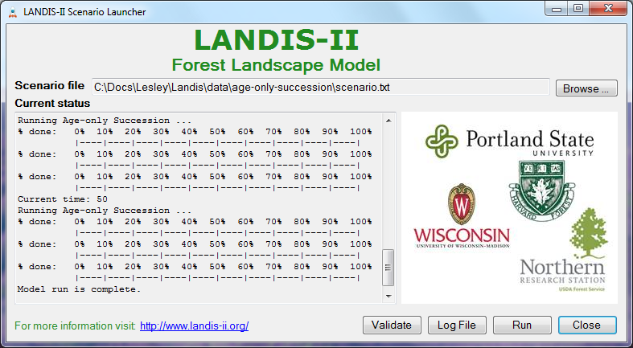

1. Use the **Browse…** button to locate the scenario text file you wish to run. This text file must comply with the general format requirements described in section 3.1 *Text Input Files* in the *LANDIS‑II Model User Guide*.
2. Use the **Validate** button to perform an initial validation of the scenario file. Note: You are not required to validate a scenario before running it.
3. Use the **Run** button to run the scenario. The current status of scenario processing will display in the **Current status** textbox. If an error occurs, the text color will change to red and the error log will be displayed in a separate window.
4. Click on the **Log** File button to view the log file after a scenario completes.
5. The following files will be generated by a scenario run: Landis-log.txt and errorLog.txt (if an error occurs). These files can be found in the working directory which is defined as the directory that contains the selected scenario file.

# Landis-II Replicator

The Replicator provides advanced batch processing capabilities allowing you to select one or more scenario files and choose the number of times to run each.

## Accessing the Replicator

The Replicator can be started from the desktop Landis-II Replicator shortcut: .

The Replicator can also be started from the Windows Start Menu: Start > LANDIS-II > v6 > Widgets > Landis-II Replicator.

## Using the Replicator

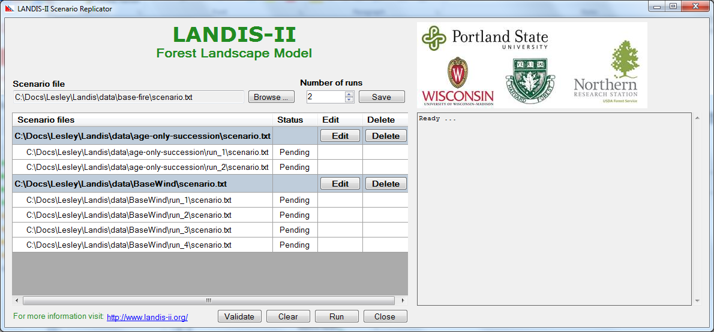

1. Use the **Browse…** button to locate the scenario text file you wish to run. This text file must comply with the general format requirements described in section 3.1 *Text Input Files* in the *LANDIS‑II Model User Guide*.
2. Set the number of runs (or times) you wish to run the scenario file and click the **Save** button to add the scenario entries to the table.
3. Use the **Edit** or **Delete** buttons to make changes to scenarios you previously configured.
4. The **Validate** button may be used to perform an initial validation of all the scenario files. The status for each scenario file will change to ‘Validated’ or ‘Failed’ as it is validated. Note: You are not required to validate a scenario before running it.
5. Use the **Run** button to run the listed scenarios. Scenario files are run sequentially and the current status of scenario processing will display in the **Current status** textbox. In addition, the status for each scenario in the table changes to ‘Running’ and finally either ‘Complete’ or ‘Failed’.
6. When the scenarios are run, the Replicator creates child folders in each working directory. The working directory is defined as the directory containing the selected scenario file. The names of these child folders are run_x where x is the ordinal of the scenario that has been run. The Landis-log.txt and errorLog.txt (if an error occurs) are saved in the run_x folder.
7. The failure of a single scenario does not stop processing. The Replicator will continue to run until it has attempted to run all planned scenarios.
8. The **Clear** button resets the form to its initial (empty) state.